EAST TEXAS AREA OF NARCOTICS ANONYMOUS
BUSINESS MEETING MINUTES September 6th, 2025

The meeting opened with Service Prayer at PM Doug H.
12 Traditions read. Hope F.
12 concepts read by Paul G.
10th concept read by ?
Roll Call –

Position | Name | Jan | Feb | March | April | May | June | July | Aug | Sep | Oct | Nov | Dec
Facilitator | Paul G | P | P | P | P | P | P | P | P | P | P
Co-Facilitator | Doug H | P | A | O | O | P | P | P | P | A | P
Notetaker |  |  |  |  |  |  |  |  |  | A | Kristen R.
Note Taker Alt | OPEN | P | O | O | O | O | O | O | O | O | O
Money Handler | Kristen | P | P | A | P | P | P | P | P | P | P
Money Handler  Alt | Debbie B | P | A | P | P | P | P | P | A | P | A
Literature Rep | Jeremy | P | A | A | P | P | P | P | P | P | A
Literature Rep Alt | Stacey H | P | O | O | O | A | P | P | P | P | P
RCM | Becki D | P | P | P | P | P | P | P | P | P | A
RCMA | OPEN | P | A | A | P | P | O | O | O | O | O
Activities | OPEN | P | O | O | O | O | O | O | O | P | O
Activities Alt | Holly B | P | A | P | A | P | A | P | A | P | P
H&I | Troy T. | A | P | P | A | A | A | O | O | O | P
H&I Alt | Brittany D. |  |  |  |  |  |  |  |  | Elected | P
PR | OPEN | P | O | O | O | O | O | O | O | O | O
PR Alt |  | O | O | O | O | O | O | O | O | O | O
Web Facilitator | Kristen (Appointed) | P | P | A | P | P | P | P | P | P | P
Web Facilitator Alt | Open | O | O | O | O | O | O | O | O | O | O

Group | Jan | Feb | March | April | May | June | July | Aug | Sep | Oct | Nov | Dec
Another Look | P | P | P | P | P | P | P | P | P | P
Candelight |  | P | P | A | P | A | A | A | P | P
The Home Group | P | P | P | P | P | P | P | P | P | P
Keep it Simple | P | P | P | P | A | P | P | P | P | A
Living Recovery | P | P | P | P | P | P | P | P | P | P
Love & Hope | P | A | A | P | P | A | P | A | P | A
New Beginnings | A | P | P | A | A | P | P | A | P | P
Recovery in Progress |  |  |  |  |  |  | P | P | P | P
Red Bud | P | P | P | P | P | P | P | P | P | P
Rising in Recovery |  |  |  |  |  |  | P | P | P | P
Visions of Recovery | P | P | P | A | P | P | A | A | P | P

MINUTES FOR SEPTEMBER - Approved.

REPORTS

Facilitator Report

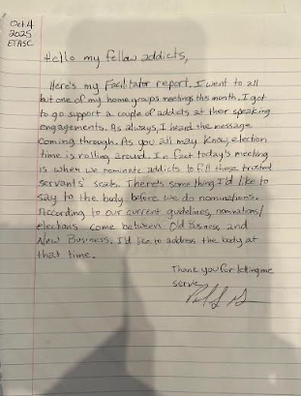
Co Facilitator
No Report.

Money Handler Report
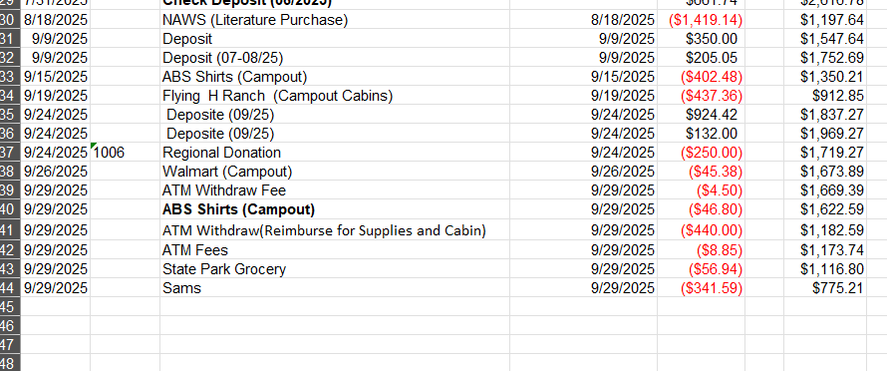

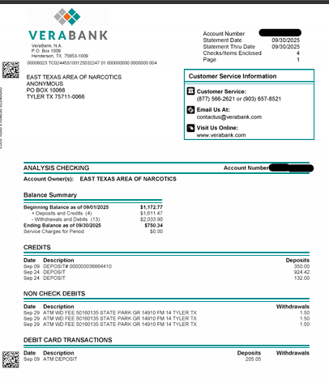

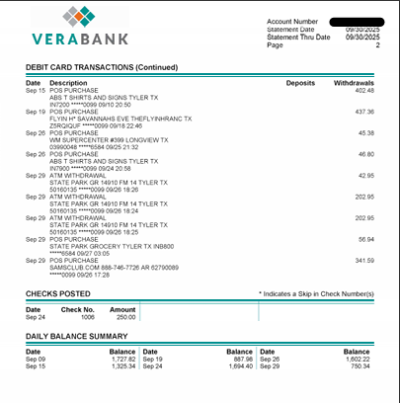

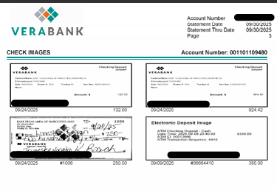

Note taker Report:

No Report; resigned by email.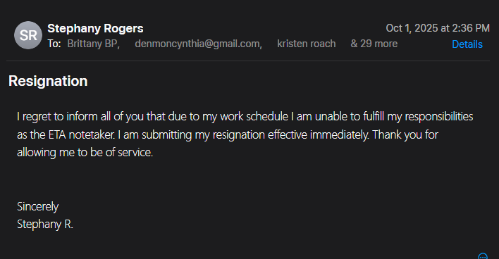

Lit Sales: $104.33
Group Donation: $228.75
7th Tradition: ($84.52 Donated to Recovery in Progress)
Total Deposit: $333.08

Literature

Literature Purchase: $0.00
Lit sales this month: $ 104.33
Last Month Lit Sales: $ 843.67
H&I Literature: $600.00

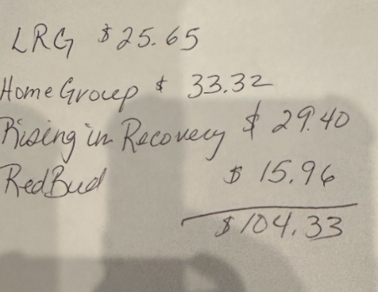

RCM

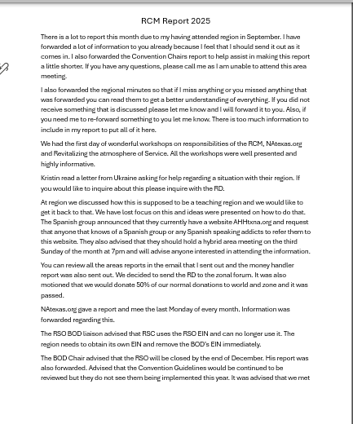
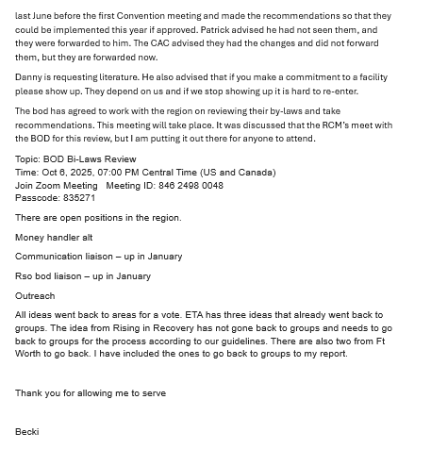

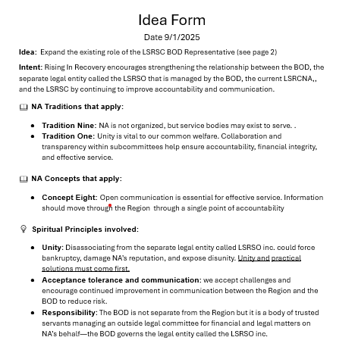

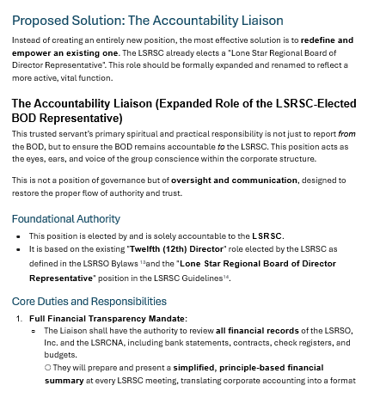

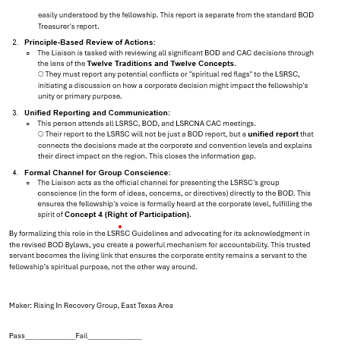

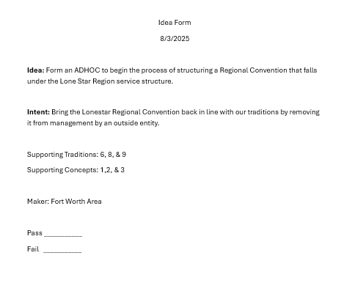
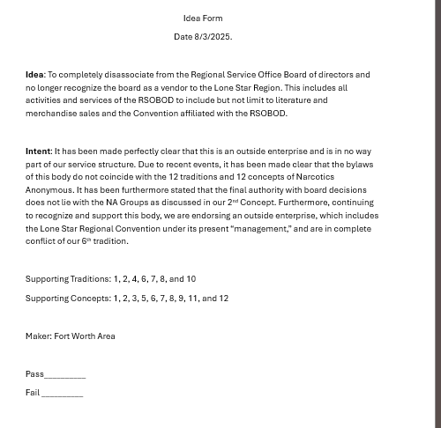

Web Facilitator

Web Facilitator stated that nothing had been done with the website in the month of September.

Activities

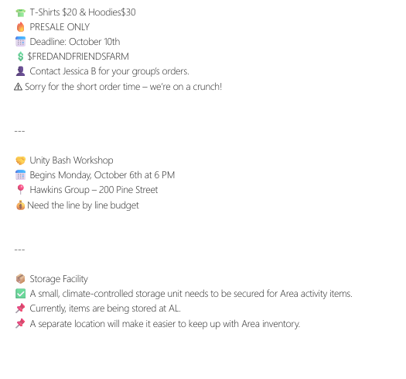
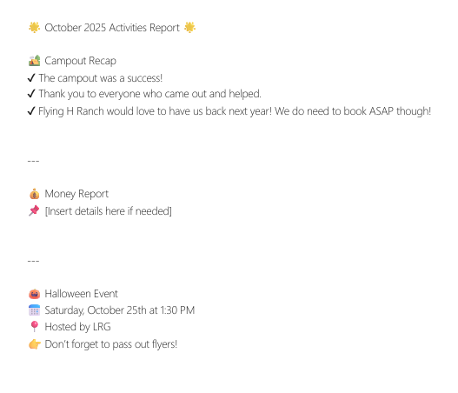

H&I
OPEN

PI
OPEN

GROUP REPORTS

ANOTHER LOOK
809 E Erwin Street Tyler, TX
M-Su @ 7PM+
S, SU@ Noon
Average Attendance 10
Donation $0
Birthday Night 1st Saturday of
Month @ 7PM; GC 2nd Sunday of the Month; Speaker Meeting 1st Friday of the Month.
Donation: $0.00

LIVING RECOVERY
107 B Wain St Longview, TX
M -TH @ 12:15AM 6PM &
8PM
F & SU @ 12:15PM & 8PM
SAT @ 12:15PM & 8PM
Avg attendance – 10
Donation $50

LOVE & HOPE
200 Pine St Hawkins, TX;
MAILING ADDRESS 220 CR
3459 Hawkins, TX
Monday @ 5pm
Sat @ 1pm.
AVG attendance – 2
Donation $0

NEW BEGINNINGS
530 N Border Tyler,
Mon Wed Fri: Noon
Tue: Noon & 8 PM
Thurs: Noon & 6 PM
Sat-Sun: 1 PM
Average Attendance 3
Last Sat of the month is BDAY night at 8pm
Donation $0.00

RED BUD:
406 Red Bud Ln in Grand
Saline, TX
Tuesday & Saturday at 7 PM;
Literature Study Thursday
7-8:30
BDAY Night is last Saturday
AVG Attendance 12
Donation $67

THE HOME GROUP
229 Utzman RD Kilgore Texas; MAILING ADDRESS 510 North
Longview St Kilgore, TX
Mon & Thur @ 6:30 PM
Average Attendance 5
Donation $20

Recovery in Progress  909 North Elm St Kemp, TX  Wednesdays @ 7PM  Average Attendance 3  Donation $20  Rising In Recovery  11915 FM 2015 Tyler, TX  Sundays @ 6PM  Average Attendance 28  Donation $29 | VISIONS OF RECOVERY  804 Jordan ST Nacogdoches,  TX  SU,W, F 7 pm Birthday Night: Last Sunday of the month. 3rd Sunday is Activities  Avg attendance 8  Donation: $42.75
OLD BUSINESS
- The tax id was asked. The money handler stated that she did not handle it. The current RCM handled it. She will send it out.
- Car Workshop 12/20 living recovery
- GSR Basics Workshop instead of Concept 10 at next area; November “25 Concept 10 & 11.
- October – Recovery in Progress
- November- Visions of Recovery
- December- Living Recovery
- Kristen will help new Notetaker put together a schedule for next year.
- Tenth Concept brought from Heather P. from Rising in Recovery against Rebecca D. RCM. There was much discussion. Heather and Becki were both given the opportunity to make a statement. Becki did apologize. There was also a complaint by the GSR from Recovery in Progress that the GSR from Rising in Recovery had sent a group text to certain individuals and she believed it was gossip and not needed at the area. This is supposed to be a place of Unity not division. The tenth concept is attached.

NEW BUSINESS

- Area Inventory
  - Take back to groups.
- Guidelines on website, printable meeting schedule
  - Yes
  - Yes Heather P. to create printable meeting schedule.
- Proposed multiarea convention
  - Needs to be talked about at the groups.
- Tax Free Status
  - Every year $250.00
  - Renewed every year.
  - Take it back to groups.
- Small storage bldg. for area
  - Activities could use but currently using another look closet.
- Book Flying H Ranch for next year.
  - Danny D wanted to table till December area meeting.
- Update Guidelines to under money handler duties to require money handler to make deposits before each area. (Red Bud)
- Heather P. Work in Progress activity for activities
- Greg S RDA
- Zoom Option for area Hybrid Meetings
- Line item for what prudent reserve covers.
  - $1800 what it covers explained to troy.
- Recording of area meetings
  - Troy
  - Accurate
  - Pull receipts.
  - Take it back to groups.

Facilitator Asked to Make Statement Before Nominations.

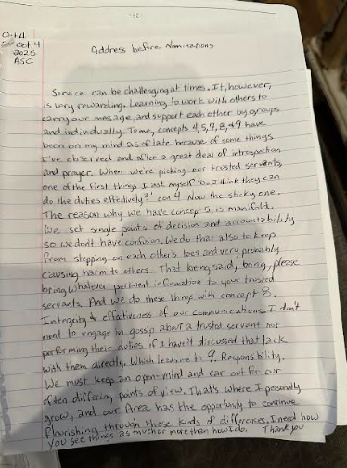

Nomination 2026

- Facilitator Paul nominated Doug Ho Red Bud
- Co-Facilitator Doug Ho nominated Paul from Red Bud
- RCMA No nominations
- Notestaker Kristen R. would like to nominated Arianna M.and Stacy B from R&R
- Notestaker Alt Hope nominates Lexi W. from Living Recovery
- Moneyhandler Alt No nominations
- Web Facilitator No nominations
- Web Facilitator Alt No nominations
- Literature Distribution Representative Hope F nominated Stacy H. from Living Recovery
- Literature Distribution Representative Alt Paul G. nominated Jeremy P. Living Recovery
- PR Heather P nominated Randy B. from Another Look
- PR Alt No nominations
- H&I Hope F nominated Troy T. Another Look
- H&I Alt Kristen R. nominated Brittany D. Rising in Recovery
- Activites Kristen nominates Holly B. Another Look
- Activities Alt Heather P nominated Brittany B from Rising in Recovery.

TAKE BACK TO GROUPS:

- Area Inventory
- Tax Free Status
- Small storage bldg. for area
  - Activities could use but currently using another look closet.
- Update Guidelines to under moneyhandler duties to require moneyhandler to make deposits before each area. (Red Bud)
- Recording of area meetings

